9.Design TM to perofrm string comparison

DESIGN:

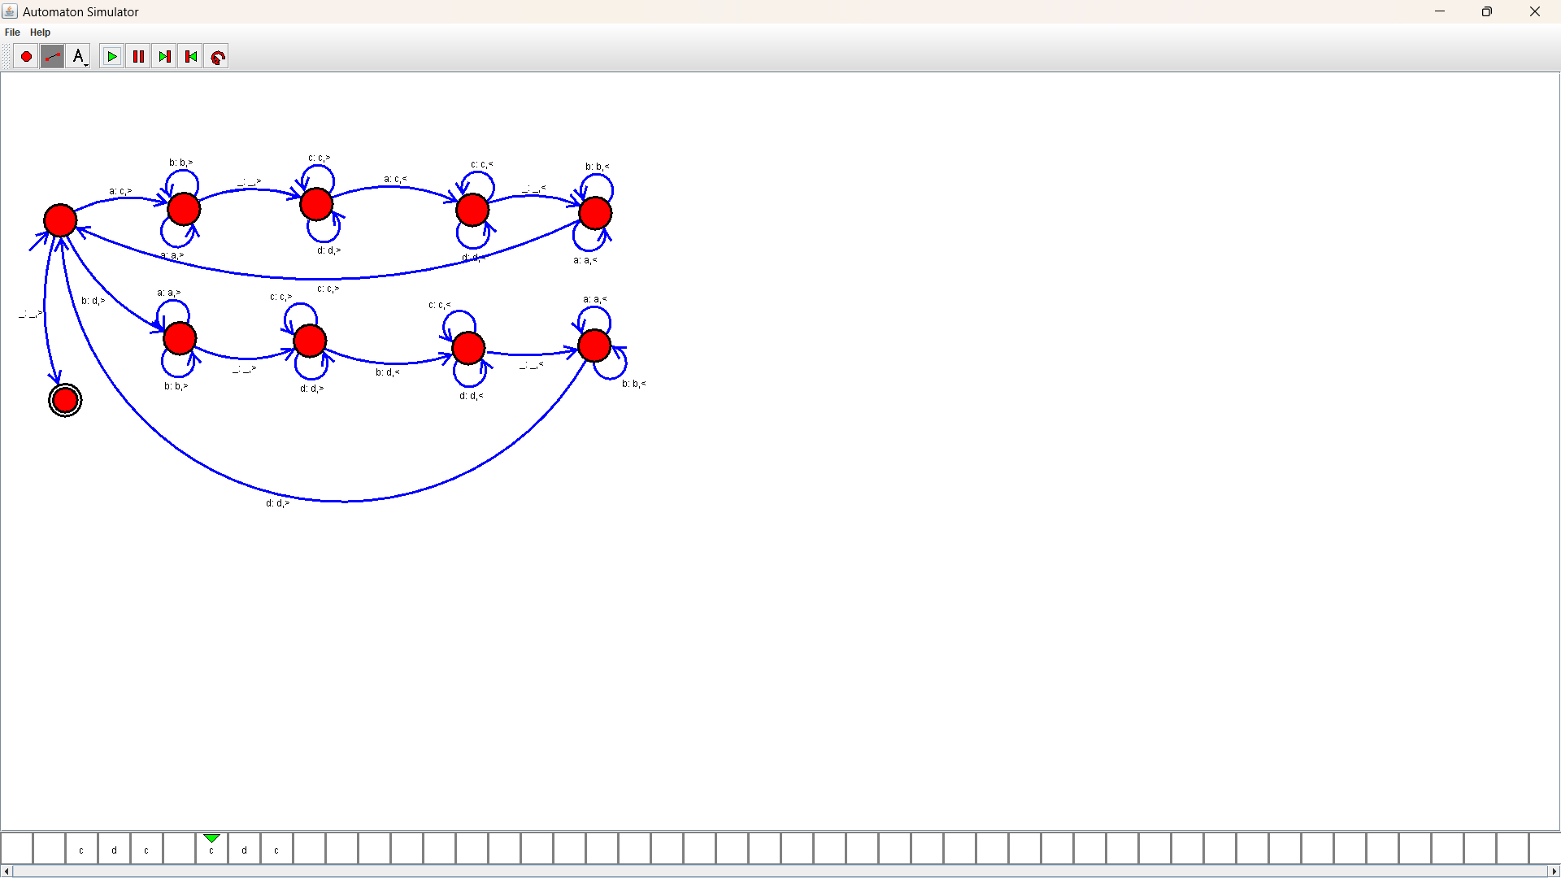

OUTPUT:

